**Data Structures and Algorithms**

**Assignment 1**

|  |  |  |  |
| --- | --- | --- | --- |
| **CLO #** | **Course Learning Outcome Statement** | | **Taxonomy Level** |
| CLO 3 | Analyze simple algorithms and determine their complexities. | | C5 |
| **Total Marks: 15** | | **Date:** | |
| **Name:** | | **ID:** | |

**Attempt All Questions only Hand written Solution will be graded**

**Read Carefully**

**Soft Copy Submission:** Through Portal

**Hard Copy Submission:** In Class

**Late Submission Policy:** 10% Deduction /24 Hours.

**Instructions: (5 marks will be deducted for not following the instructions)**

* Viva can be conducted OR a Quiz will be taken on the basis of assignment.
* Attempt all questions in sequence. Attach this title page as a front page of assignment.
* Assignment should be handwritten/printed on A4 sized page. **(No pages from register please.)**
* Submit Hard copy in class and scanned copy of solved assignment on the portal **(Both copies should be submitted before deadline)**

**Total Marks: 15 (70% Assignment + 30% Evaluation)**

**Answers Clarity:** Justify your answer where needed.

**Question # 1:**   **(5 Marks)**

Find the line by line and overall complexity of the following codes:

|  |
| --- |
| #include <iostream>  int main ( ) {  int n;  cin>> n;  for (int i=0; i<n; i++) {  cout<< “Assignment 1”;  }  } |

|  |
| --- |
| sum = 0;  for (int i=0; i<n; i++)  for (int j=1; j<l; j++)  if (i<j == 0)  for (int k=0; k<j; k++)  sum++; |

**Question # 2:**  **(10 Marks)**

Write a code to implement the following operation on a given array.

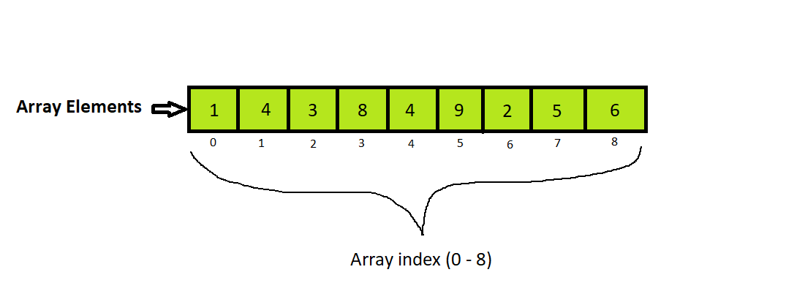

1. Insert 10 at ‘0’ index.
2. Delete 3rd index or element 8.

**Hint: You don’t need to take input of size and element of the array from user.**

**Write its code using templates.**

Good Luck